**ST8701 Introduction to Programming for Data Science**

**What you will learn / do in this lab**

1. What is the Spyder IDE?
2. How to launch the Spyder IDE software
3. How to write and run Python code using Spyder IDE

**Table of Contents**

1. Overview 2

A. What you will do for this lab 2

B. Intro to Jupyter Notebook 2

C. Conventions used in Jupyter Notebook 2

Jupyter notebooks 2

notebook kernel 3

Notebook Dashboard 3

2. Running the Jupyter Notebook App 4

A. Create a folder to store your notebooks 4

B. Launch app manually (Method 1) 4

C. Launch app via shortcut (Method 2) 5

D. Customize start-up directory 6

3. Create your first Jupyter notebook 9

A. My First Jupyter notebook 9

# Overview

## What you will do for this lab

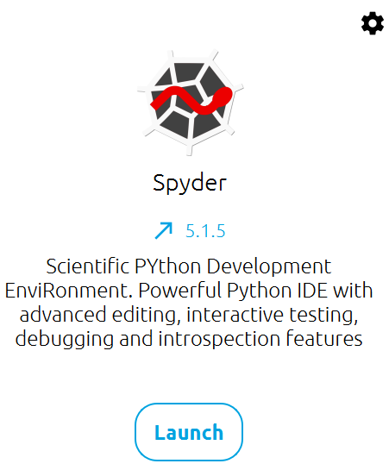

In this lab, you will learn what is the Spyder IDE (Integrated Development Environment) and how it can be used to write and run Python programs in this module.

## Intro to Spyder

Spyder stands for the **S**cientific **PY**thon **D**evelopment **E**nvi**R**onment.

Basically, it is a text editor like your familiar NOTEPAD on Windows, but much more powerful.

In this module, we will be at times, using Spyder to edit our Python code. Not all the time, because we will also be using another software as well – Jupyter Notebook.

Spyder is a feature-rich interactive development environment for the Python language with advanced editing, interactive testing, debugging and introspection features and a numerical computing environment.

It comes with a built-in IPython (Interactive Python interpreter) and popular Python libraries such as NumPy (linear algebra), SciPy (signal and image processing) or matplotlib (interactive 2D/3D plotting).

# Use Spyder

In this section, you will learn how to launch the Spyder app on your laptop and start using it.



## Start up Spyder



| No | Task | | |
| --- | --- | --- | --- |
|  | Download Link: <https://www.spyder-ide.org/>  Please download Spyder 5.3.x and above.  Note: Spyder 5.1.x has issued. | |  |
|  | Invoke the Spyder software on your laptop by pressing **Windows key + S** then search for **Spyder** | |  |
|  | Click on the Spyder icon to start the app |  | |
|  | After a while, the Spyder application will load up and you should see the following interface as shown below. | | |
|  | | | |

# Create your first Python program in Spyder

In this section, you will create and run your first Python program using Spyder.



## My First Python program in Spyder

| No | Task | |
| --- | --- | --- |
|  | In the Spyder software, click menu “File->New” or press “Ctrl-N” to start a new file | |
|  | Type the following code inside the text area | |
| |  | | --- | | message = "Hello World!"  print(message) | | | |
|  | Click the save icon or press “Ctrl-S”, and save the file as “helloworld.py” on your Desktop. | |
|  | Click the “Run” icon on the toolbar.  Alternatively, you can also press “F5” |  |
|  | You should see output similar to that below on the right-hand side of the screen as shown below | |
|  | | |
|  | Congratulations! You have just written your first Python code in Spyder and ran it successfully! 😊 | |

**-- End of Practical --**